Arduino Based Dual Axes Smart Solar Tracker

|  |  |  |
| --- | --- | --- |
| SHOUMI, ANANYA BISWAS  18-38781-3  *Department of EEE*  *American International University- Bangladesh (AIUB)*  [18-38781-3@student.aiub.edu](mailto:18-38781-3@student.aiub.edu)  MR. ISMAIL HOSSAIN  19-41088-2  *Department of CSE*  *American International University- Bangladesh (AIUB)*  [19-41088-2@student.aiub.edu](mailto:19-41088-2@student.aiub.edu) | MD. IMRAN HOSSAIN  18-39243-3  *Department of EEE*  *American International University- Bangladesh (AIUB)*  [18-39243-3@student.aiub.edu](mailto:18-39243-3@student.aiub.edu)  MD. RATUL AMAN  18-39130-3  *Department of EEE*  *American International University- Bangladesh (AIUB)*  [18-39130-3@student.aiub.edu](mailto:18-39130-3@student.aiub.edu)  AVIJIT SARKER TONMOY  19-39983-1  *Department of CSE*  *American International University-*  *Bangladesh (AIUB)*  [19-39983-1@student.aiub.edu](mailto:19-39983-1@student.aiub.edu) | SOURAV BARMAN  18-36696-1  *Department of CSE*  *American International University-*  *Bangladesh (AIUB)*  [18-36696-1@student.aiub.edu](mailto:18-36696-1@student.aiub.edu)  MD. MUSFIQUR RAHMAN  19-40008-1  *Department of CSE*  *American International University-*  *Bangladesh (AIUB)*  [19-40008-1@student.aiub.edu](mailto:19-40008-1@student.aiub.edu) |

**Abstract:** In the current era, the world is moving toward the various energy sources in between; one of them is renewable energy. This renewable energy source is due to pollution and the cost of non-renewable energy sources. Amon many sources, the Sun is significant renewable energy [1]. This project aims to maximize energy output to reduce panel temperature and increase the PV panel's efficiency. Small-scale solar is developed through complete hardware and software to function accurately [2]. Arduino is used to rotating the solar panel. In addition, solar trackers are used to improving solar energy's power gain. Solar power change is for seasonal variation and depending on the position of the Sun in the sky. Dual-axis solar tracking allows more energy to produce because the solar array can remain aligned perpendicular to the sun [3].

# Keywords: Arduino, Solar power, PV, Dual-axis Solar Taker, Servomotor, Solar Panel.

# INTRODUCTION

# In recent decades’ solar energy has emerged as a possible renewable energy source. Solar energy is converted into electrical energy according to the PV effect by using solar panels. Solar energy is widely used in various projects because it is simple to use—a solar tracking system designed with microcontrollers and LDR’s. The LDR incorporated on the solar panel helps detect sunlight, which moves the panel accordingly. The solar tracker described a more improved way to maximize the power consumption by the solar panel from the sun by just rotating the solar panel according to the sun’s position. By comparing the results, it was discovered that the sun's direct beam helps generate more energy than produced when the solar panel is kept fixed [1].

# The sun's energy is the prime source, and it is considered the fuel for most renewable systems. The photovoltaic (PV) system replaces the sun's energy resources. Electrical energy comes directly from the solar energy conversion through inverters and solar panels. These panels are constructed from silicon and germanium

# semiconductor materials with low efficiency. To increase the performance, the intensity of light falling on the solar panel should be increased. Solar trackers are considered the most suitable technology to enhance efficiency. The enhancement is carried out by keeping the solar panels tracking the sun's position. Recently, trackers have been a common way to increase efficiency despite the increasing cost [2].

**LITERATURE REVIEW**

Previously, people used solar energy in a fixed panel between the east and west with approximately 30 degrees towards the south. this is not ideal. It a better to orient the panels toward the sun by using double axes. Many researchers have published papers on this subject. An efficient microcontroller-based sun tracker control for solar cell systems is introduced for fossil fuel [2].

Ghazanfar Mehdia et al. (2019) designed a sun tracker where the sun position is sensed using phototransistors connected to the frame and mounted on a simple structure. The internet of things (IoT) is one of the future control approaches in intelligent buildings and industries with interconnected micro-grids [2].

**METHODOLOGY AND MODELING**

The project aims to develop a cost-effective instrument using an Arduino Microcontroller-based solar tracking system using a Bluetooth module for detecting voltage and getting the result in an Android app. The Block diagram of the complete system is shown in Fig. 1 below, which consists of a power supply, Arduino Uno, LDR sensor, servo motor, solar panel, a collective sensor, a microcontroller. The sensor unit is an LDR Light Dependent Resistor and an LM35 temperature sensor. The LDR functions in the presence and absence of light. The LDR function detects the sunlight to obtain the direction of the solar irradiation maximum power. The LDR movement tracking will increase the concentration of the energy by the solar that assists to realize its function efficiently.

Figure-01: block diagram of dual axes solar tracker

**WORKING PRINCIPLE**

In this system, four LDRs are fixed to sense light intensity. First, the analog signal from the sensors is given to the in-built ADC and light comparison unit. This output is provided as an input to the Arduino board along with the input command. Next, the output of the Arduino is given to the motor driving circuit. Two DC motors are connected with the driving circuit, one for vertical and horizontal movement. The motor rotates the solar panel perpendicular to the position of the sun’s rays. Then finally, the output power is displayed on the LCD. The LDR combination plays an important role [1].

When the motor gets the last bit pattern, it will move the panel to its initial position and follow these steps when the sun starts rising the next day. First, a load is taken from the solar panel by connecting the panel with the battery and inverter. The battery stores and gives DC supply to the inverter, taken from the solar panel. Then the output DC supply was given to the inverter, which converts DC to AC. Then a load is connected along with it [2].

**IMPORTANT COMPONENT**

*1. Solar panel*

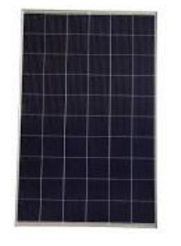The solar panel works based on the principle of the photovoltaic effect, which converts solar energy into electrical energy. Various panels are available, like monocrystalline, polycrystalline, amorphous, and hybrid.

Figure-02 Solar panel

The Amorphous solar panel is shown in the above Figure. The cost and silicon requirement of an amorphous panel are low compared to the other types of solar panels [1].

*2. Arduino board*

Arduino board is an open-source microcontroller that controls the movement of solar panels that rotates the direction of the sun. It's an open-source platform to build an electronics project. It is equipped with analog and digital input-output, 14 digital pins, six analog inputs, a 16 MHz crystal oscillator, a USB connection, a power jack, and a reset button. The input command was given to the Arduino using the Integrated Development Environment platform [1].

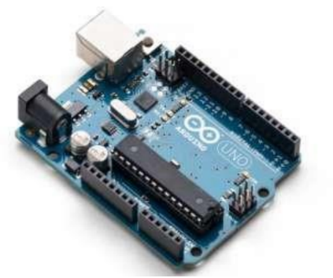

Figure-03 Arduino board

*3. SERVO motor*

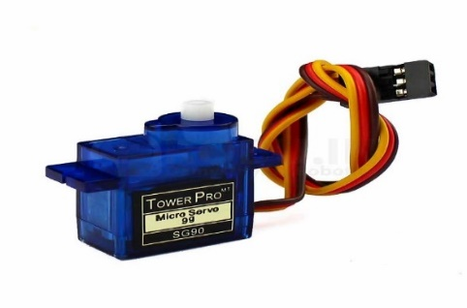A servo motor is a rotary actuator that allows controlling angular position, velocity, and acceleration. It consists of a motor coupled to a sensor for position feedback. Servomotors are used in robotics, CNC machinery, or automated manufacturing. It is highly used in solar tracking systems.

Figure-04 SERVO motor

*4. Motor driver*

A motor driver undoubtedly makes the motor move as per the given instructions or the inputs (high and low). It listens to the low voltage from the controller/processor and controls an actual motor that needs high input voltage.

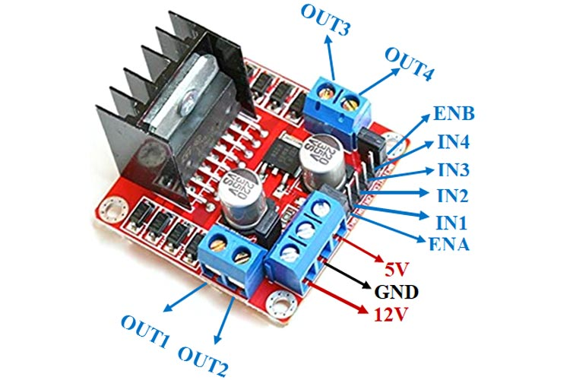Motor and driver efficiency improves because the driver is better matched with the motor, eliminating additional wiring between the motor and the driver. The long wiring runs add to wasted power directly and indirectly.

Figure-05 Motor driver

*5. Inverter*

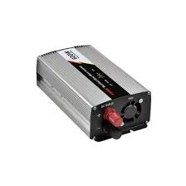The inverter is a device that changes DC to AC. It is not the same as an alternator, which converts mechanical energy into alternating current. Instead, an inverter usually increases the voltage. An inverter accomplishes the DC-to-AC conversion by switching the direction of a DC input back and forth very rapidly.

Figure-06 inverter

**RESULTS AND DISCUSSION**

The compact and low power system is successfully done after designing, developing, and implementing the intelligent solar tracker system for voltage measurement and solar panel efficiency. First, the system is tested at different times in varying sun orientations to detect the incident light in other conditions. Then, the output is taken with the help of panel movement according to maximum efficiency. Finally, the developed system provides results and output in the android device through transmission from the controller, and we get a real-time measurement on the mobile app.

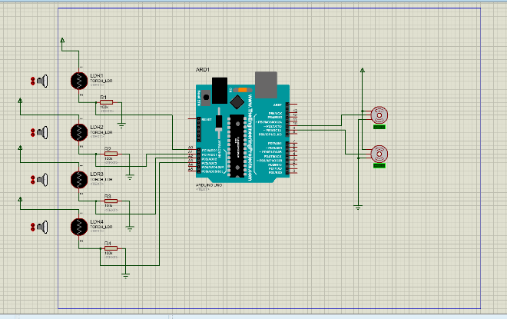

Figure-07

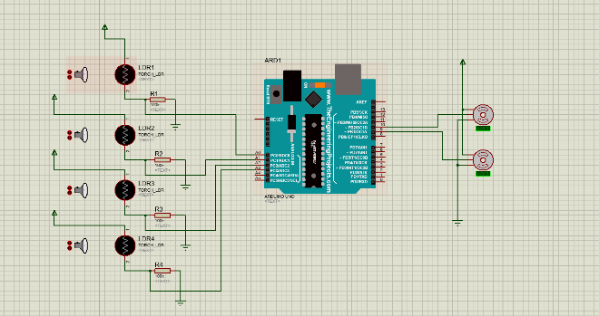

Figure-08

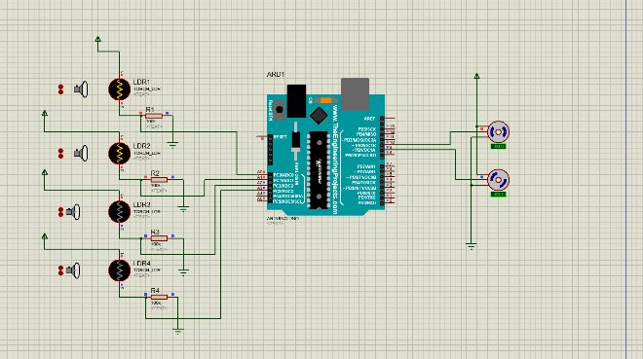

Figure-09

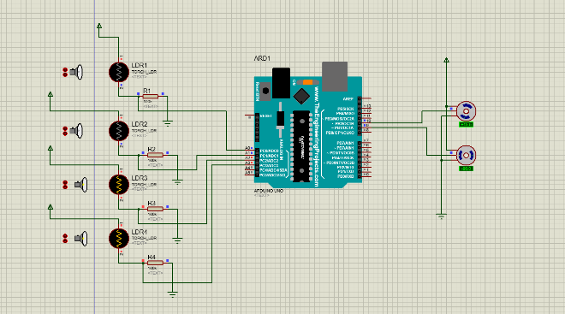

Figure-10

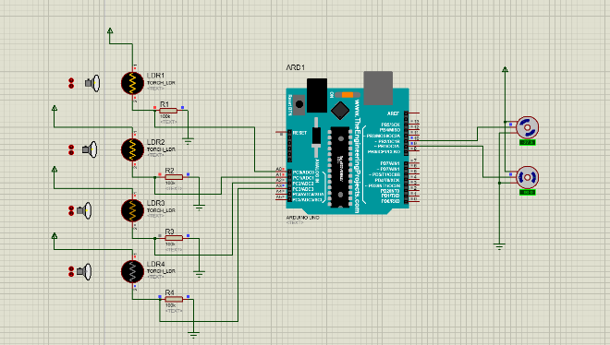

Figure-11

**CONCLUSION**

Arduino-based Dual Axis Smart Solar Tracker is successfully implemented to increase the efficiency of solar panels. The proposed project is more effective than the existing single-axis solar tracker, which automatically tracks the sun's maximum solar power with the help of an Arduino board. It is implementation simple. Finally, the experimental system reveals that the system is effective in both good and bad weather. During different periods compared with the existing system, and efficiency of the solar panel is effectively improved.

Further, the advantages and disadvantages were also studied. The disadvantages were the challenges that had to be overcome. From this study, the main conclusions are

i. The proposed system is low-cost and compact compared to the other tracking systems for the same application.

ii. It is straightforward to program and modify because it is Arduino-based, and no external programmer is required.

iii. The designed system is easy to use and provides better panel efficiency.

iv. In the developed system, real-time data is retrieved on the android device.

**REFERENCES**

[1] A. Karthika, S. Jayanthi1, G. Deivamani, “DUAL AXIS SOLAR TRACKING SYSTEM USING ARDUINO”. In the International Research Journal of Engineering and Technology (IRJET)

[2] Khalaf S Gaeid, M Nasir Uddin, Mohamed K Mohamed, Omar N Mohmmoud, “Design and Implement of Dual Axis Solar Tracker System Based Arduino”. In the Tikrit Journal of Engineering Sciences (2020) 27 (2): 71-81. Article history: Received 07 Dec. 2019 Accepted 10 May 2020 Available online 01 July 2020.

[3] Sunil Kumar Jilledi, Daniel Tesfazgi, Filmon Foto, Mahmud Ali, Abduselam Atta, Alexander Yemane, “Design and Simulation of Dual Axis Solar Tracker for Optimum Solar Energy Absorption”. In the International Journal of Sensors and Sensor Networks. Vol. 7, No. 3, 2019, pp. 34-43. doi: 10.11648/j.ijssn.20190703.11 Received: July 31, 2019; Accepted: August 29, 2019; Published: September 19, 2019.

[4] Jyoti Mishra, Ritula Thakur, Alok Deep, “Arduino based Dual Axis Smart Solar Tracker”. In International Journal of Advanced Engineering, Management and Science (IJAEMS) [Vol-3, Issue-5, May- 2017], ISSN: 2454-1311, <https://dx.doi.org/10.24001/ijaems.3.5.20> .